Interview Questions

Q1: How do you currently book meeting rooms?
We currently book meeting rooms manually by contacting the person responsible for room reservations. We need to ask about room availability and agree on a suitable date and time before confirming the booking.

Q2: What problems do you face when scheduling meetings?
The main problems are difficulty checking room availability, overlapping reservations, and wasting time arranging meeting schedules. Sometimes, we need to change the meeting time because the room is already booked.

Q3: What features would you like to have in the new system?
I would like the system to show available rooms, allow users to book rooms online, and provide booking confirmations. It should also allow users to cancel or modify reservations easily.

Q4: Do you currently use a system to manage room bookings?
No, we do not currently use a dedicated booking system. We depend on manual methods to record reservations and check room availability, which can sometimes lead to mistakes.

Q5: Do you need booking confirmation after reserving a room?
Yes, booking confirmation is important because it helps users make sure that their reservations have been recorded successfully. It also reduces confusion and prevents misunderstandings about booking details.

Q6: Do you prefer booking rooms online or in person?
I prefer booking rooms online because it is faster and more convenient. It allows users to check available rooms and reserve them without needing to visit the responsible employee.

Q7: Do you prefer automatic booking notifications or manual notifications?
I prefer automatic notifications because they inform users immediately about their booking status. They can also remind users of upcoming meetings and notify them if a reservation is changed or canceled.

Q8: Can you explain more about the problems you face when booking a room?
Sometimes, users cannot easily know which rooms are available at a specific time. This may cause two users to request the same room, resulting in booking conflicts and delays. A centralized system could help solve these problems.

Q9: How often do booking conflicts happen?
Booking conflicts happen occasionally, especially when several meetings are scheduled on the same day. They usually occur because reservations are not updated immediately or users do not have access to the latest room schedules.

Q10: Why do you think the current booking process needs improvement?
The current process needs improvement because it takes time and effort to manage reservations manually. A computerized booking system could organize schedules, reduce human errors, improve room utilization, and make the reservation process easier for everyone.

Questionnaire
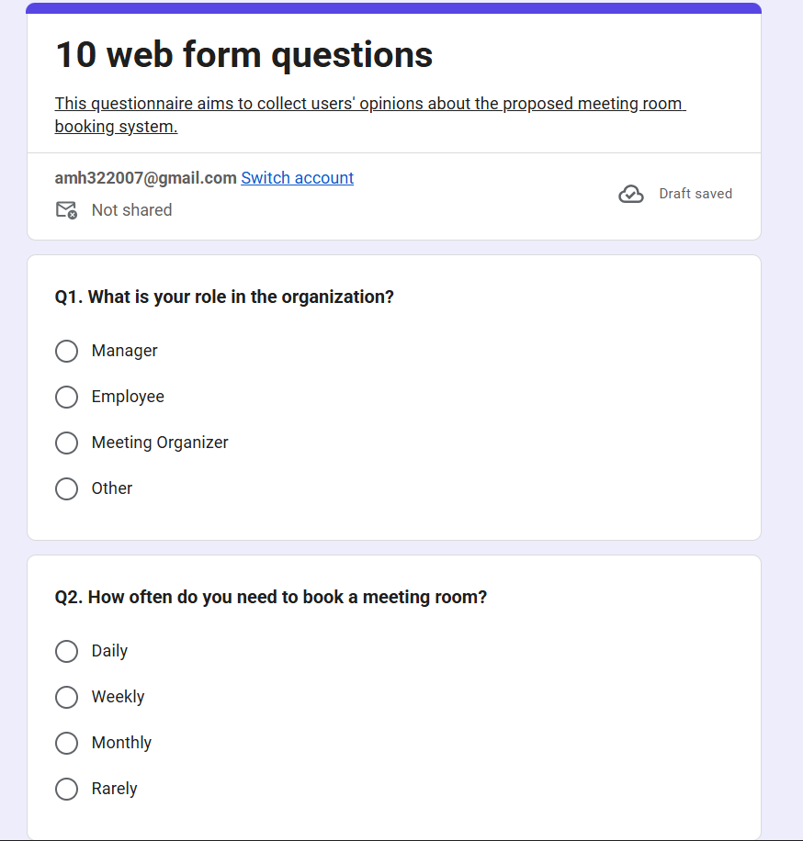

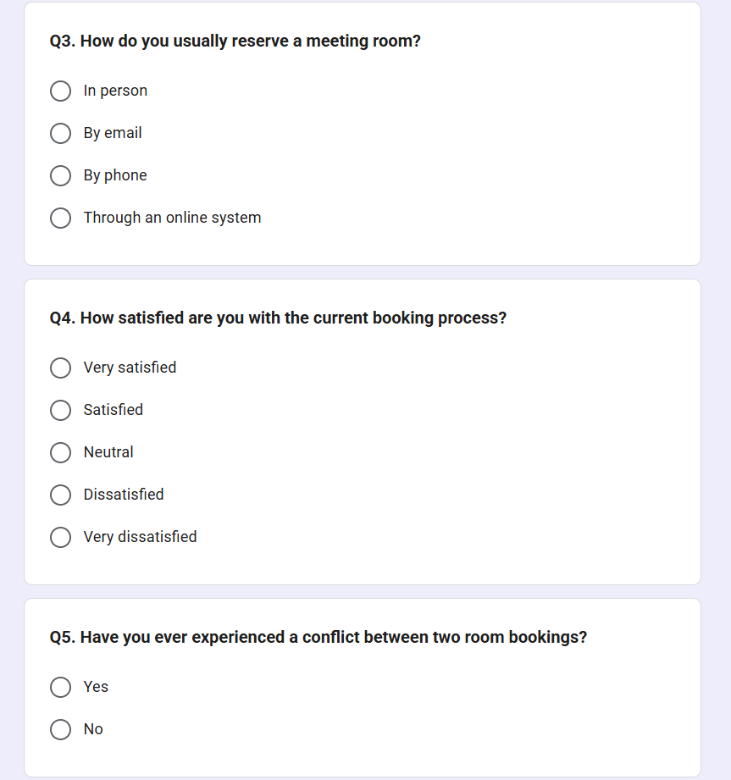

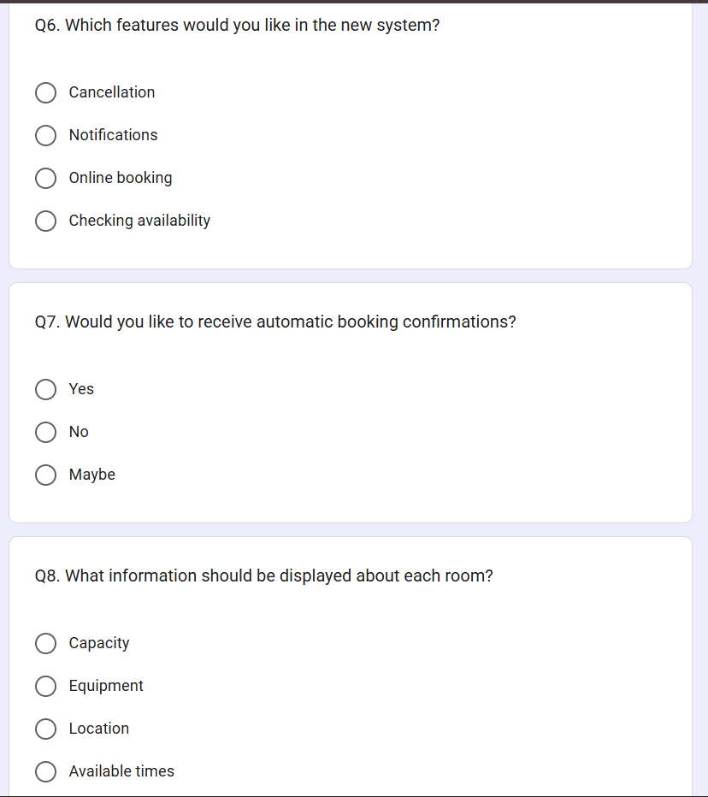

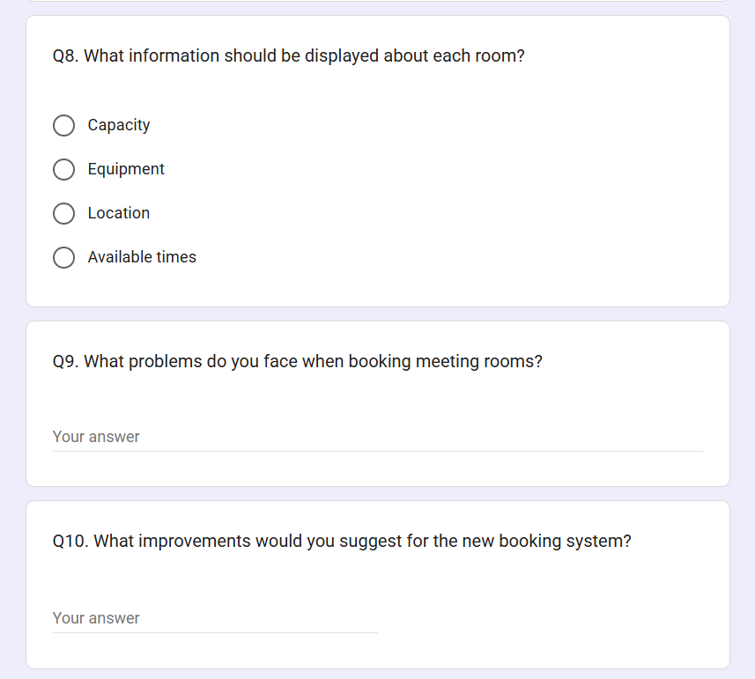

Interview Report
- Project Name: Meeting Room Booking System
- Person Interviewed: Mr. Ahmed
- Interviewer: Ahmed Allam

- Purpose of Interview :
- To understand how meeting rooms are currently booked and managed.
- To identify the main problems users face when reserving meeting rooms.
- To collect requirements and suggestions for the proposed system.
- To understand how the new system can save time and reduce booking conflicts.

- Interview Opinion :
The interviewee believes that the current manual booking process needs improvement. A computerized system would make it easier to check room availability and organize reservations. He also believes that the proposed system could reduce scheduling errors and make the booking process faster and more efficient.
- Interview Feelings :
The interviewee feels that the current process can be time-consuming and confusing, especially when several people need to book rooms at the same time. He is interested in having a simple and organized system that allows users to make reservations easily and receive confirmation of their bookings.

- Current State of the System :
Currently, meeting rooms may be booked manually by contacting the person responsible for reservations. Users may need to ask about available rooms and suitable times before confirming a booking. This can cause delays, overlapping reservations, and difficulties when schedules are not updated regularly. Managing bookings manually also requires additional time and effort.

- System Goals :
- To display available meeting rooms and their details.
- To allow users to book rooms for specific dates and times.
- To prevent booking conflicts and duplicate reservations.
- To allow users to modify or cancel their bookings.
- To provide booking confirmations and notifications.
- To save time and reduce manual work.
- To improve the organization and utilization of meeting rooms.

- Summary of Interview :
The interview highlighted the need for a centralized system to manage meeting rooms and their reservations. The proposed system should provide accurate availability information, simplify the booking process, and help users manage their reservations efficiently.

- Open Items :
- Display room capacity, location, and available equipment.
- Prevent two users from booking the same room at the same date and time.
- Allow users to modify or cancel reservations.
- Provide booking confirmations and notifications.
- Keep room schedules and booking information updated.

- Detailed Notes :
The interview focused on the existing booking process, its main problems, and the expected features of the new system. The collected information will help the project team identify the system requirements and prepare the analysis and design documents.

